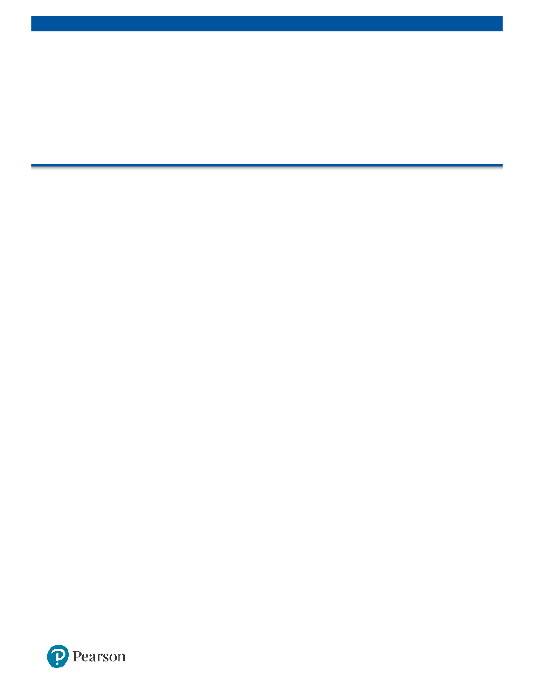

WISC®-V

Wechsler Intelligence Scale for Children®-Fifth Edition

Score Report



|  |  |  |  |  |
| --- | --- | --- | --- | --- |
| Examinee Name | Kendall Mittleider |  | Date of Report | 06/03/2024 |
| Examinee ID |  |  | Grade |  |
| Date of Birth | 11/01/2015 |  | Primary Language |  |
| Gender | Female |  | Handedness |  |
| Race/Ethnicity |  |  | Examiner Name | Draper, Whitney |

|  |  |  |  |  |  |  |
| --- | --- | --- | --- | --- | --- | --- |
| Date of Testing | 04/30/2024 |  | Age at Testing | 8 years 5 months |  | Retest? No |

Comments:

**PRIMARY SUMMARY**

|  |
| --- |
| **Subtest Score Summary** |

|  |  |  |  |  |  |  |  |
| --- | --- | --- | --- | --- | --- | --- | --- |
| **Domain** | **Subtest Name** |  | **Total**  **Raw Score** | **Scaled**  **Score** | **Percentile**  **Rank** | **Age**  **Equivalent** | ***SEM*** |
| Verbal | **Similarities** | SI | 17 | 8 | 25 | 6:10 | 1.16 |
| Comprehension | **Vocabulary** | VC | 20 | 10 | 50 | 8:6 | 1.24 |
|  | (Information) | IN | - | - | - | - | - |
|  | (Comprehension) | CO | - | - | - | - | - |
| Visual Spatial | **Block Design** | BD | 22 | 10 | 50 | 8:6 | 1.04 |
|  | Visual Puzzles | VP | 14 | 11 | 63 | 9:2 | 1.08 |
| Fluid Reasoning | **Matrix Reasoning** | MR | 17 | 11 | 63 | 8:10 | 0.99 |
|  | **Figure Weights** | FW | 13 | 7 | 16 | 6:10 | 0.73 |
|  | (Picture Concepts) | PC | - | - | - | - | - |
|  | (Arithmetic) | AR | - | - | - | - | - |
| Working Memory | **Digit Span** | DS | 23 | 11 | 63 | 9:2 | 0.95 |
|  | Picture Span | PS | 23 | 10 | 50 | 8:2 | 1.08 |
|  | (Letter-Number Seq.) | LN | - | - | - | - | - |
| Processing Speed | **Coding** | CD | 43 | 14 | 91 | 10:6 | 1.37 |
|  | Symbol Search | SS | 23 | 12 | 75 | 10:2 | 1.34 |
|  | (Cancellation) | CA | - | - | - | - | - |

Subtests used to derive the FSIQ are bolded. Secondary subtests are in parentheses.

**PRIMARY SUMMARY (CONTINUED)**

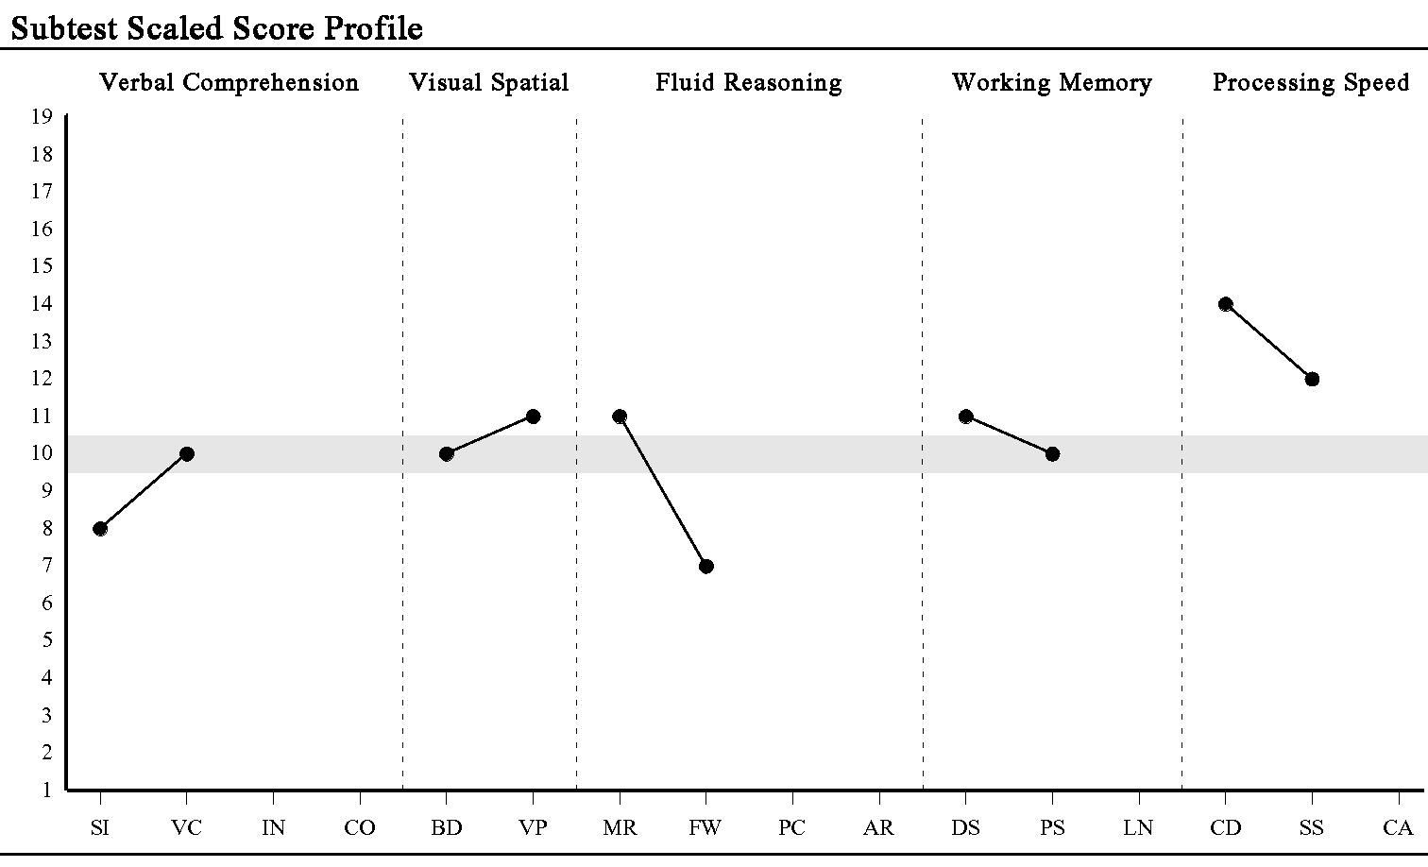

|  |
| --- |
| **Composite Score Summary** |

|  |  |  |  |  |  |  |  |
| --- | --- | --- | --- | --- | --- | --- | --- |
| **Composite** |  | **Sum of**  **Scaled Scores** | **Composite**  **Score** | **Percentile Rank** | **95% Confidence**  **Interval** | **Qualitative Description** | ***SEM*** |
| Verbal Comprehension | VCI | 18 | 95 | 37 | 88-103 | Average | 4.74 |
| Visual Spatial | VSI | 21 | 102 | 55 | 94-109 | Average | 4.24 |
| Fluid Reasoning | FRI | 18 | 94 | 34 | 87-102 | Average | 3.67 |
| Working Memory | WMI | 21 | 103 | 58 | 95-110 | Average | 4.24 |
| Processing Speed | PSI | 26 | 116 | 86 | 105-123 | High Average | 5.61 |
| Full Scale IQ | FSIQ | 71 | 101 | 53 | 95-107 | Average | 3.00 |

Confidence intervals are calculated using the Standard Error of Estimation.

**PRIMARY ANALYSIS**

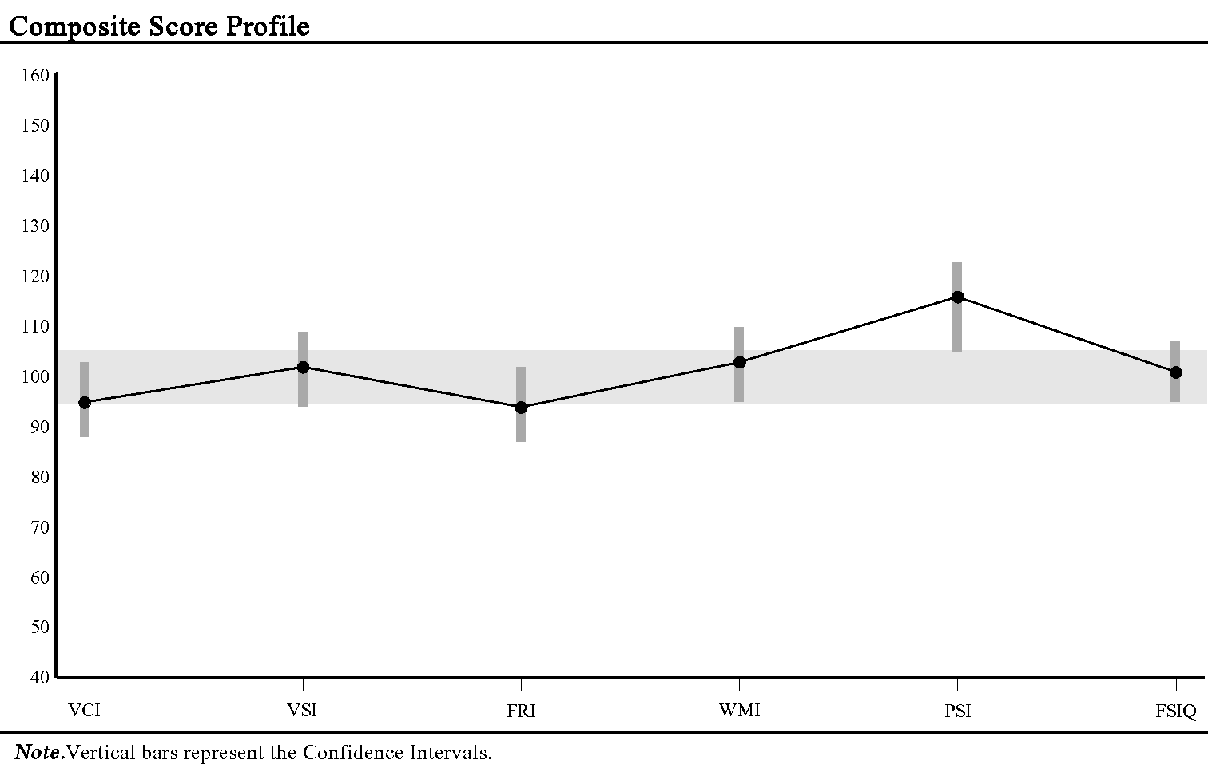

|  |
| --- |
| **Index Level Strengths and Weaknesses** |

|  |  |  |  |  |  |  |
| --- | --- | --- | --- | --- | --- | --- |
| **Index** | **Score** | **Comparison**  **Score** | **Difference** | **Critical Value** | **Strength or**  **Weakness** | **Base Rate** |
| VCI | 95 | 102.0 | -7.0 | 10.79 |  | <=25% |
| VSI | 102 | 102.0 | 0.0 | 9.93 |  |  |
| FRI | 94 | 102.0 | -8.0 | 8.98 |  | <=25% |
| WMI | 103 | 102.0 | 1.0 | 9.93 |  | >25% |
| PSI | 116 | 102.0 | 14.0 | 12.33 | S | <=15% |

Comparison score mean derived from the five index scores (MIS).

Statistical significance (critical values) at the .05 level.

Base rates are reported by ability level.

|  |
| --- |
| **Index Level Pairwise Difference Comparisons** |

|  |  |  |  |  |  |  |
| --- | --- | --- | --- | --- | --- | --- |
| **Index Comparison** | **Score 1** | **Score 2** | **Difference** | **Critical Value** | **Significant Difference** | **Base Rate** |
| VCI - VSI | 95 | 102 | -7 | 12.46 | N | 33.4% |
| VCI - FRI | 95 | 94 | 1 | 11.75 | N | 48.6% |
| VCI - WMI | 95 | 103 | -8 | 12.46 | N | 30.8% |
| VCI - PSI | 95 | 116 | -21 | 14.39 | Y | 12.9% |
| VSI - FRI | 102 | 94 | 8 | 10.99 | N | 29.5% |
| VSI - WMI | 102 | 103 | -1 | 11.75 | N | 50.8% |
| VSI - PSI | 102 | 116 | -14 | 13.78 | Y | 23.0% |
| FRI - WMI | 94 | 103 | -9 | 10.99 | N | 30.1% |
| FRI - PSI | 94 | 116 | -22 | 13.14 | Y | 12.5% |
| WMI - PSI | 103 | 116 | -13 | 13.78 | N | 23.2% |

Statistical significance (critical values) at the .05 level.

Base rates are reported by ability level.

**PRIMARY ANALYSIS (CONTINUED)**

|  |
| --- |
| **Subtest Level Strengths and Weaknesses** |

|  |  |  |  |  |  |  |
| --- | --- | --- | --- | --- | --- | --- |
| **Subtest** | **Score** | **Comparison**  **Score** | **Difference** | **Critical Value** | **Strength or**  **Weakness** | **Base Rate** |
| SI | 8 | 10.4 | -2.4 | 3.07 |  | <=15% |
| VC | 10 | 10.4 | -0.4 | 3.26 |  | >25% |
| BD | 10 | 10.4 | -0.4 | 2.78 |  | >25% |
| VP | 11 | 10.4 | 0.6 | 2.88 |  | >25% |
| MR | 11 | 10.4 | 0.6 | 2.67 |  | >25% |
| FW | 7 | 10.4 | -3.4 | 2.08 | W | <=10% |
| DS | 11 | 10.4 | 0.6 | 2.58 |  | >25% |
| PS | 10 | 10.4 | -0.4 | 2.88 |  | >25% |
| CD | 14 | 10.4 | 3.6 | 3.57 | S | <=10% |
| SS | 12 | 10.4 | 1.6 | 3.50 |  | <=25% |

Comparison score mean derived from the ten primary subtest scores (MSS-P).

Statistical significance (critical values) at the .05 level.

|  |
| --- |
| **Subtest Level Pairwise Difference Comparisons** |

|  |  |  |  |  |  |  |
| --- | --- | --- | --- | --- | --- | --- |
| **Subtest Comparison** | **Score 1** | **Score 2** | **Difference** | **Critical Value** | **Significant Difference** | **Base Rate** |
| SI - VC | 8 | 10 | -2 | 3.02 | N | 25.0% |
| BD - VP | 10 | 11 | -1 | 3.04 | N | 42.4% |
| MR - FW | 11 | 7 | 4 | 2.60 | Y | 13.4% |
| DS - PS | 11 | 10 | 1 | 2.89 | N | 41.6% |
| CD - SS | 14 | 12 | 2 | 3.63 | N | 27.7% |

Statistical significance (critical values) at the .05 level.

**ANCILLARY & COMPLEMENTARY SUMMARY**

|  |
| --- |
| **Index Score Summary** |

|  |  |  |  |  |  |  |  |
| --- | --- | --- | --- | --- | --- | --- | --- |
| **Composite** |  | **Sum of Scaled/**  **Standard Scores** | **Index**  **Score** | **Percentile Rank** | **95%**  **Confidence**  **Interval** | **Qualitative Description** | ***SEM*** |
| **Ancillary** |  |  |  |  |  |  |  |
| Verbal (Expanded Crystallized) | VECI | - | - | - | - | - | - |
| Expanded Fluid | EFI | - | - | - | - | - | - |
| Quantitative Reasoning | QRI | - | - | - | - | - | - |
| Auditory Working Memory | AWMI | - | - | - | - | - | - |
| Nonverbal | NVI | 63 | 103 | 58 | 97-109 | Average | 3.35 |
| General Ability | GAI | 46 | 95 | 37 | 90-101 | Average | 3.00 |
| Cognitive Proficiency | CPI | 47 | 113 | 81 | 105-119 | High Average | 4.24 |
| **Complementary** |  |  |  |  |  |  |  |
| Naming Speed | NSI | - | - | - | - | - | - |
| Symbol Translation | STI | - | - | - | - | - | - |
| Storage & Retrieval | SRI | - | - | - | - | - | - |

Ancillary index scores are reported using standard scores.

**ANCILLARY & COMPLEMENTARY SUMMARY (CONTINUED)**

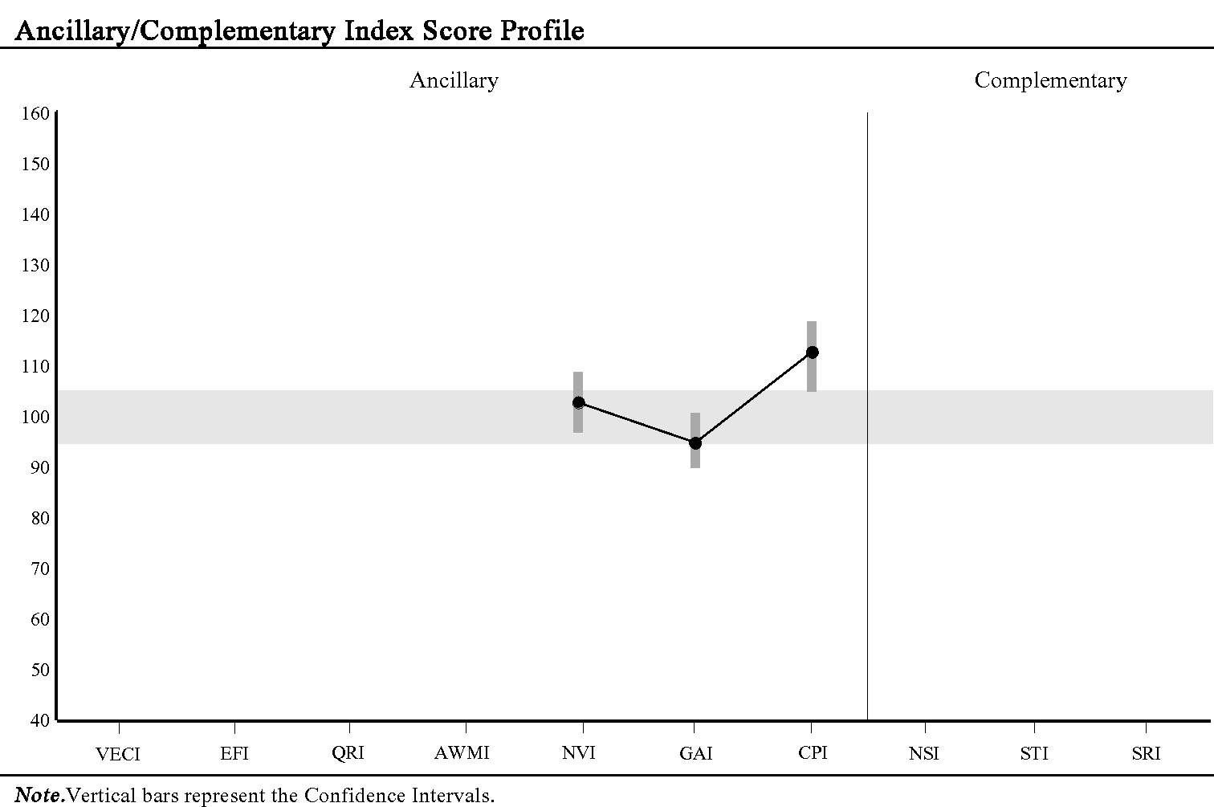

|  |
| --- |
| **Subtest Score Summary** |

|  |  |  |  |  |  |  |  |
| --- | --- | --- | --- | --- | --- | --- | --- |
| **Scale** | **Subtest/Process Score** |  | **Total**  **Raw Score** | **Standard**  **Score** | **Percentile**  **Rank** | **Age**  **Equivalent** | ***SEM*** |
| Naming Speed | Naming Speed Literacy | NSL | - | - | - | - | - |
|  | Naming Speed Quantity | NSQ | - | - | - | - | - |
| Symbol Translation | Immediate Symbol Translation | IST | - | - | - | - | - |
|  | Delayed Symbol Translation | DST | - | - | - | - | - |
|  | Recognition Symbol Translation | RST | - | - | - | - | - |

**ANCILLARY & COMPLEMENTARY ANALYSIS**

|  |
| --- |
| **Index Level Pairwise Difference Comparisons** |

|  |  |  |  |  |  |  |
| --- | --- | --- | --- | --- | --- | --- |
| **Index Comparison** | **Score 1** | **Score 2** | **Difference** | **Critical Value** | **Significant Difference** | **Base Rate** |
| **Ancillary** |  |  |  |  |  |  |
| GAI - FSIQ | 95 | 101 | -6 | 3.58 | Y | 7.7% |
| GAI - CPI | 95 | 113 | -18 | 10.18 | Y | 7.5% |
| WMI - AWMI | - | - | - | - | - | - |
| **Complementary** |  |  |  |  |  |  |
| NSI - STI | - | - | - | - | - | - |

Statistical significance (critical values) at the .05 level.

Base rates are reported by ability level.

|  |
| --- |
| **Subtest Level Pairwise Difference Comparisons** |

|  |  |  |  |  |  |  |
| --- | --- | --- | --- | --- | --- | --- |
| **Subtest Comparison** | **Score 1** | **Score 2** | **Difference** | **Critical Value** | **Significant Difference** | **Base Rate** |
| **Ancillary** |  |  |  |  |  |  |
| FW - AR | - | - | - | - | - | - |
| DS - LN | - | - | - | - | - | - |
| **Complementary** |  |  |  |  |  |  |
| NSL - NSQ | - | - | - | - | - | - |
| IST - DST | - | - | - | - | - | - |
| IST - RST | - | - | - | - | - | - |
| DST - RST | - | - | - | - | - | - |

**PROCESS ANALYSIS**

|  |
| --- |
| **Total Raw Score to Standard Score Conversion** |

|  |  |  |  |  |
| --- | --- | --- | --- | --- |
| **Process Score** |  | **Raw Score** | **Standard Score** |  |
| Naming Speed Size-Color-Object | NSsco | - | - |  |
| Naming Speed Letter-Number | NSln | - | - |  |

|  |
| --- |
| **Process Level Pairwise Difference Comparisons (Standard Scores)** |

|  |  |  |  |  |  |  |
| --- | --- | --- | --- | --- | --- | --- |
| **Process Score Comparison** | **Score 1** | **Score 2** | **Difference** | **Critical Value** | **Significant Difference** | **Base Rate** |
| NSsco - NSln | - | - | - | - | - | - |

|  |
| --- |
| **Total Raw Score to Scaled Score Conversion** |

|  |  |  |  |  |
| --- | --- | --- | --- | --- |
| **Process Score** |  | **Raw Score** | **Scaled Score** |  |
| Block Design No Time Bonus | BDn | - | - |  |
| Block Design Partial Score | BDp | - | - |  |
| Digit Span Forward | DSf | 9 | 12 |  |
| Digit Span Backward | DSb | 7 | 10 |  |
| Digit Span Sequencing | DSs | 7 | 11 |  |
| Cancellation Random | CAr | - | - |  |
| Cancellation Structured | CAs | - | - |  |

|  |
| --- |
| **Process Level Pairwise Difference Comparisons (Scaled Scores)** |

|  |  |  |  |  |  |  |
| --- | --- | --- | --- | --- | --- | --- |
| **Process Score Comparison** | **Score 1** | **Score 2** | **Difference** | **Critical Value** | **Significant Difference** | **Base Rate** |
| BD - BDn | - | - | - | - | - | - |
| BD - BDp | - | - | - | - | - | - |
| DSf - DSb | 12 | 10 | 2 | 3.69 | N | 28.7% |
| DSf - DSs | 12 | 11 | 1 | 3.63 | N | 42.9% |
| DSb - DSs | 10 | 11 | -1 | 3.66 | N | 42.9% |
| LN - DSs | - | - | - | - | - | - |
| CAr - CAs | - | - | - | - | - | - |

Statistical significance (critical values) at the .05 level.

**PROCESS ANALYSIS (CONTINUED)**

|  |
| --- |
| **Total Raw Score to Base Rate Conversion** |

|  |  |  |  |  |
| --- | --- | --- | --- | --- |
| **Process Score** |  | **Raw Score** | **Base Rate** |  |
| Longest Digit Span Forward | LDSf | - | - |  |
| Longest Digit Span Backward | LDSb | - | - |  |
| Longest Digit Span Sequence | LDSs | - | - |  |
| Longest Picture Span Stimulus | LPSs | - | - |  |
| Longest Picture Span Response | LPSr | - | - |  |
| Longest Letter-Number Sequence | LLNs | - | - |  |
| Block Design Dimension Errors | BDde | - | - |  |
| Block Design Rotation Errors | BDre | - | - |  |
| Coding Rotation Errors | CDre | - | - |  |
| Symbol Search Set Errors | SSse | - | - |  |
| Symbol Search Rotation Errors | SSre | - | - |  |
| Naming Speed Literacy Errors | NSLe | - | - |  |
| Naming Speed Size-Color-Object Errors | NSscoe | - | - |  |
| Naming Speed Letter-Number Errors | NSlne | - | - |  |
| Naming Speed Quantity Errors | NSQe | - | - |  |

|  |
| --- |
| **Process Level Pairwise Difference Comparisons (Raw Scores)** |

|  |  |  |  |  |
| --- | --- | --- | --- | --- |
| **Process Score Comparison** | **Raw Score 1** | **Raw Score 2** | **Difference** | **Base Rate** |
| LDSf - LDSb | - | - | - | - |
| LDSf - LDSs | - | - | - | - |
| LDSb - LDSs | - | - | - | - |

**End of Report**